Power BI Visualization: It is a pictorial or graphical representation of data which helps to understand complex data.

Types of Power BI Visualizations

A. Charts
Charts are graphical representations of data in Power BI. Use them to simplify complex data sets and make it easier to understand and interpret the data. Power BI offers a variety of chart types, each suited to different kinds of data and different data visualization tasks.

1. Bar Charts:
They are a simple and effective way to display categorical data, allowing users to compare and analyze data across different categories. Bar charts are ideal for showcasing quantitative data where the values are not too large, making them suitable for various purposes like comparing sales figures, analyzing customer demographics, and visualizing performance metrics.

Types of Bar Charts
- Clustered Bar/ Column Chart: This is the most common type of bar chart, where bars are grouped for each category, allowing for easy comparison of values within the same category.

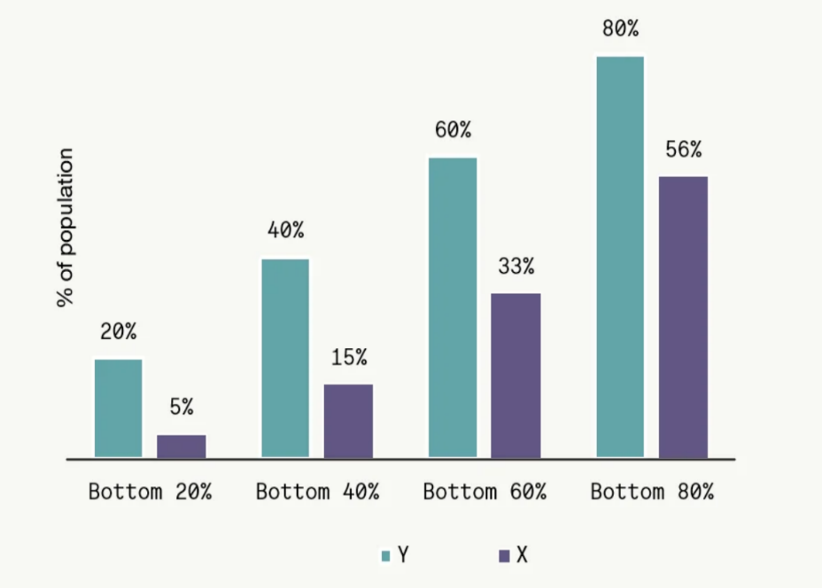

- Stacked Bar Chart: In this chart, the bars are stacked vertically, representing the contribution of each category to a total value. This is useful for visualizing the composition of a whole and identifying the dominant categories.
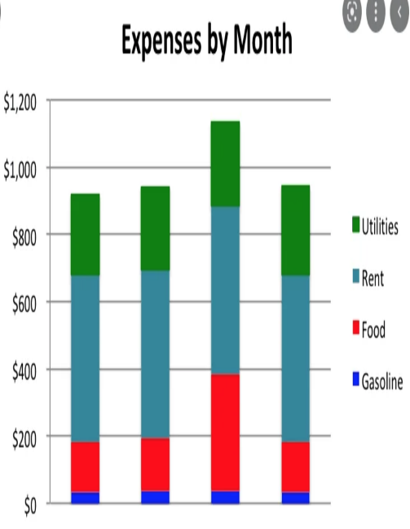

- 100% Stacked Bar Chart: Similar to the stacked bar chart, the bars always sum up to 100%, making it ideal for showing percentages and proportions.
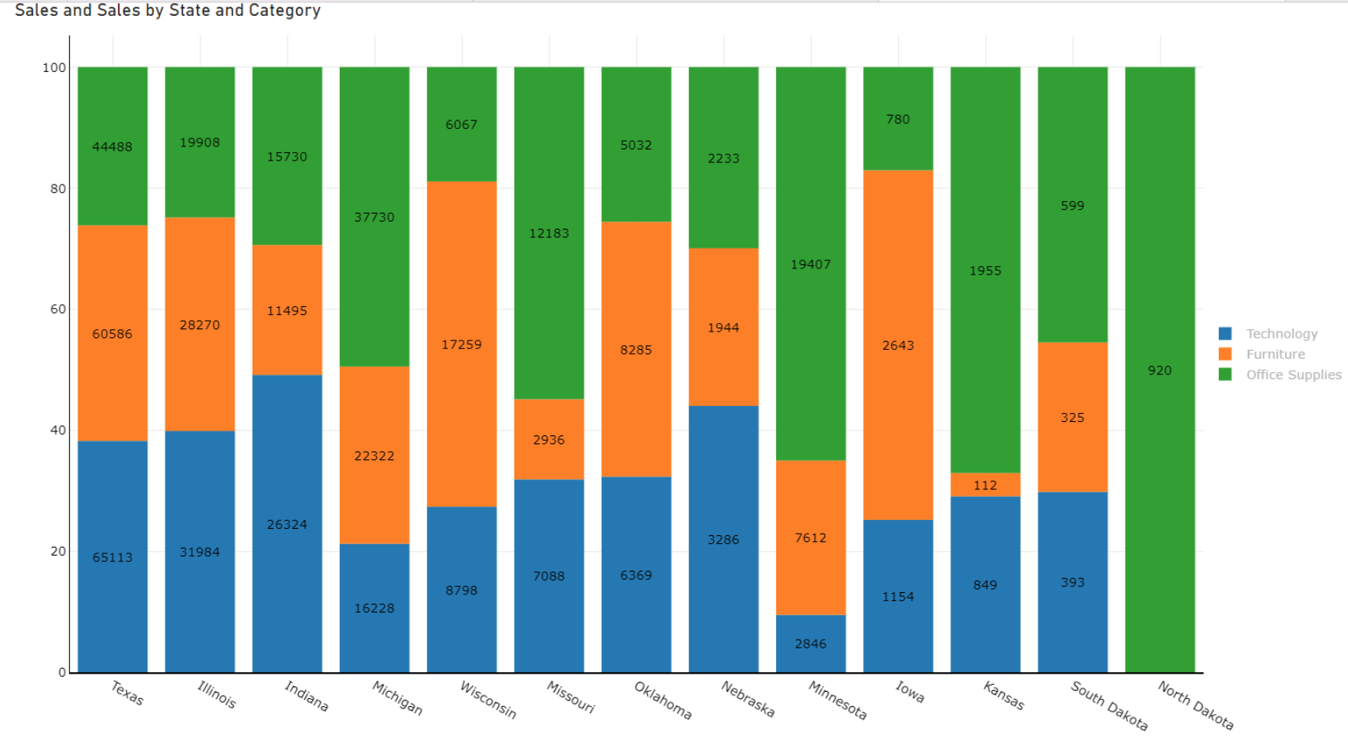
.

2. Area chart
There are two main types of area charts in Power BI:

Basic Area Chart
This is the most common type of area chart. It displays data points as a line, with the area between the line and the axis filled with color. Basic area charts help show trends over time or compare different categories of data.
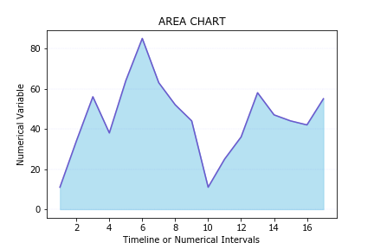

Stacked Area Chart
A stacked area chart shows multiple categories of data stacked on top of each other. This chart type is useful for showing how different categories contribute to a whole.

Choosing the Right Type of Area Chart
The best type of area chart to use will depend on your specific data and needs. Here are some things to consider:
- The number of data points you have. If you have a lot of data points, you may want to use a basic area chart or a stacked area chart with a smaller number of categories.
- The type of data you have. If your data is continuous, you can use a line chart or an area chart. If your data is categorical, you can use a bar chart or a column chart.

3. Line Charts:
Power BI uses a line chart to visually represent data points connected by straight lines. Users employ it to visualize trends and patterns over time or across categories, making it ideal for continuous data such as time series data, stock market trends, sales figures, etc.
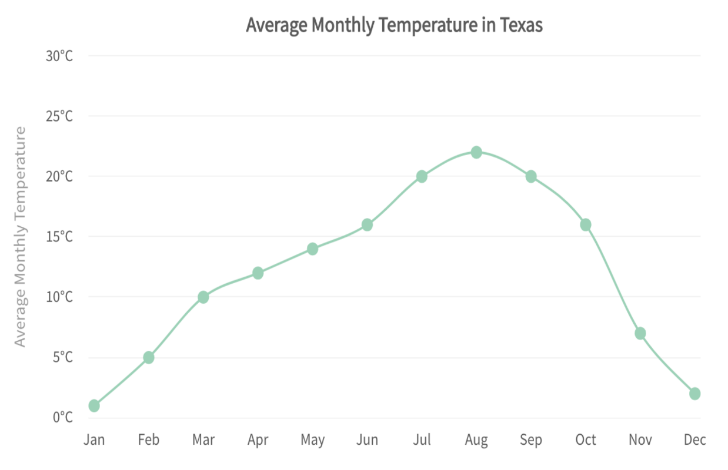

Power BI Slicers:
Power BI slicers are interactive controls that allow you to filter the data displayed in your reports. They are visual filters that can be placed directly onto a report canvas, enabling users to interact with them to filter visuals displayed on a report page.
There are four types of slicers:
- Dropdowns
- Vertical lists
- Tiles
- Date pickers

How to Create Power BI Slicers
To add a slicer to your report, simply choose the slicer visual from the list of visualizations in the right-hand pane of Power BI Desktop. After that, add the fields you want to use to filter your report.

Selection controls
A few options allow you to control how items are selected in a slicer. These are single select, multi-select with CTRL, and whether to show the "Select all" option.

How To Use Drill Down And Up Options In Power BI?
Power BI’s Drill down and drill-up tools enable users to explore several levels of data hierarchy to acquire insights into specific areas of interest.

Drill Down
- Select a visual or chart that contains hierarchical data. For example, a chart that shows sales data by region, state, and city.
- Click on the data point that you want to drill down into. For example, click on the region name to drill down from the regional to the state level.
- Click on the “Drill down” button in the visualization pane or right-click on the data point and select “Drill down.”
- The chart will update to show the data at a more granular level. For example, if you drill down from the region to the state level, the chart will show sales data by state.

Drill Up
- Select a visual or chart that contains hierarchical data.
- Right-click on the visual or chart and select “Drill up” or click the “Drill up” button in the visualizations pane.
- The chart will update to show the data at a higher level of granularity. For example, if you drill down from the regional to the state level, the chart will show sales data by region.
Point to be Noted: Drill-down and drill-up options may not be available for all visualizations or charts in Power BI, and it depends on the data hierarchy you have created. Also, the exact steps may vary depending on the version of Power BI you are using.

